**Connected graph:**

The **graph *G* is connected if there is a path between every pair of vertex** otherwise it is said to be **Disconnected Graph.**

**Examples:**

**1**

.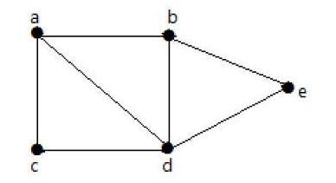

Above figure is connected graph because there exist a path between every vertex of the graph i.e. you can reach from any given vertex to every vertex through a walk**. It is not necessary that there should exist an edge between every pair of vertex in a connected graph.**

2. In the following example, traversing from vertex ‘a’ to vertex ‘f’ is not possible because there is no path between them directly or indirectly. Hence it is a disconnected graph.

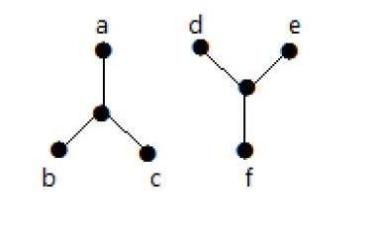

Note: Please correct the definition of connected and disconnected graph in your note copy also otherwise you will get confuse.